Ideation Phase
Define the Problem Statements

Date | 20-02-2026
Team ID | LTVIP2026TMIDS79278
Project Name | Electric Motor Temperature Prediction Using Machine Learning
Maximum Marks | 2 Marks

Customer Problem Statement Template:
Industrial operators and maintenance engineers struggle with unexpected electric motor overheating, which causes equipment failure, production downtime, and increased maintenance costs. Traditional temperature sensors increase system complexity and cost while providing limited predictive capability.
They need a reliable, cost-effective, and real-time temperature prediction system that uses existing motor sensor data to accurately estimate Permanent Magnet surface temperature and prevent failures before they occur.
Industrial operators and maintenance engineers struggle with unexpected electric motor overheating, which causes equipment failure, production downtime, and increased maintenance costs. Traditional temperature sensors increase system complexity and cost while providing limited predictive capability.
They need a reliable, cost-effective, and real-time temperature prediction system that uses existing motor sensor data to accurately estimate Permanent Magnet surface temperature and prevent failures before they occur.
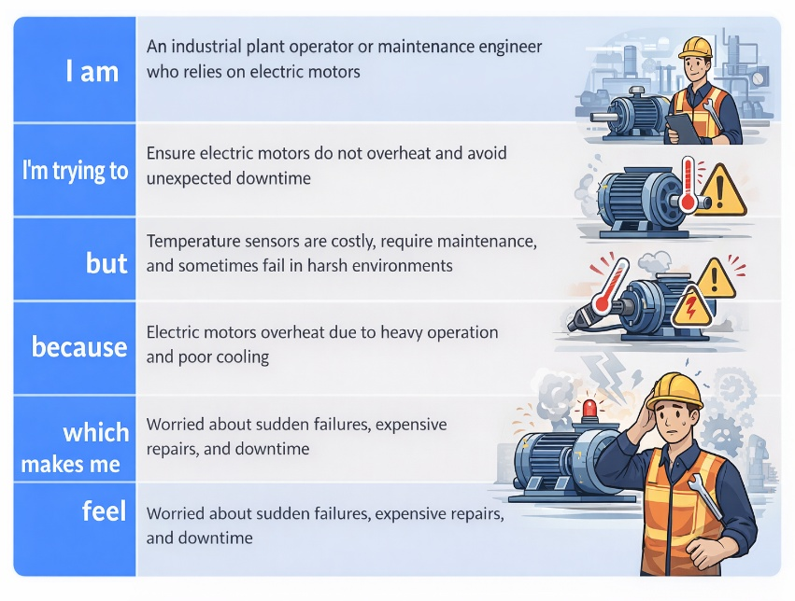
Reference: https://miro.com/templates/customer-problem-statement/

